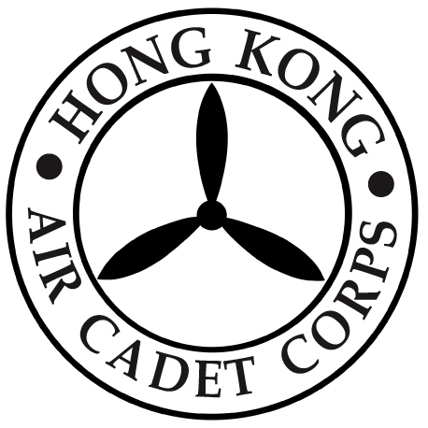

HONG KONG AIR CADET CORPS

From : HQ  Ref : GR19_002 | To : Unit Commanders  Cc : Major Unit Commanders
Tel : 2712 8900  Fax : 2715 6944 | Date: 18 January 2019

HQ Close Early on 4 February 2019

Please be informed that the Headquarters office will be closed early at 1300 hrs on the Chinese New Year’s Eve (4 February 2019).

Should you have any enquiry, please contact HQ staff by phone at 2712 8900 or by email to hq@aircadets.org.hk .

Megan TIN
Administrative Manager

